

Atlantic Coast Exotics, LLC PROCURE TO PAY PROCESS FLOW DOCUMENT
Paapri Cloud Technology

Process Flow:
STEP 1: To create a Purchase order follow the navigation below:
Transactions -> Purchases -> Enter Purchase Orders
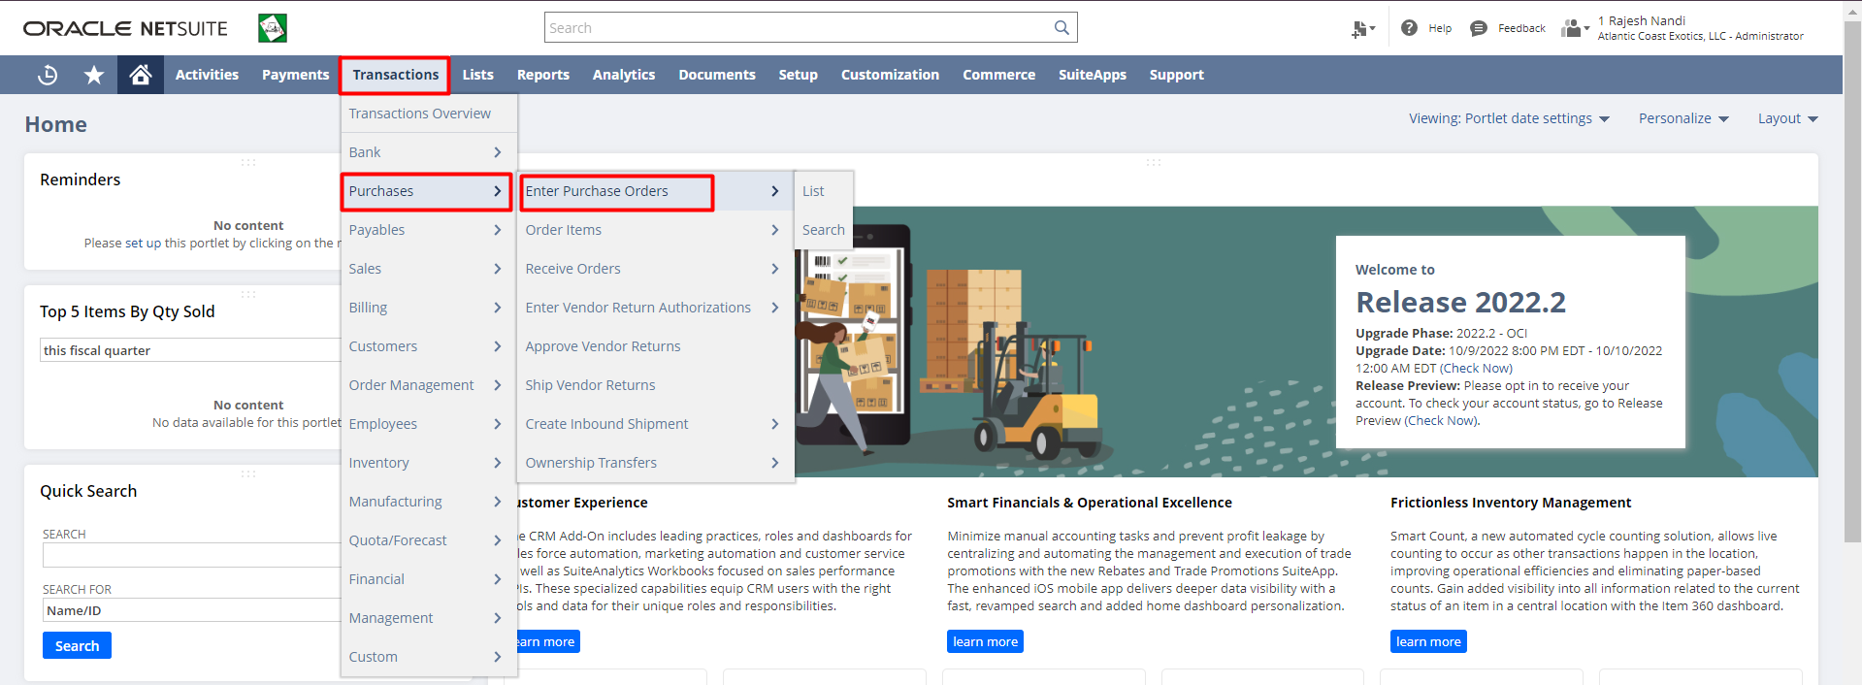
STEP 2: Enter the details for the Purchase Order (Mandatory Fields-Vendor) for the raw materials/finished goods.
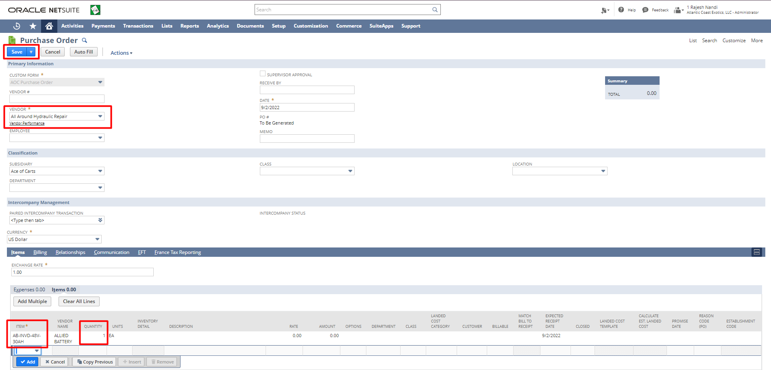
Select the Items from the Item dropdown. Enter the quantity. Click the “Add” button to add the item. Click the “Save” button.
STEP 3: If the Purchase order needs to be printed, hit the print button.
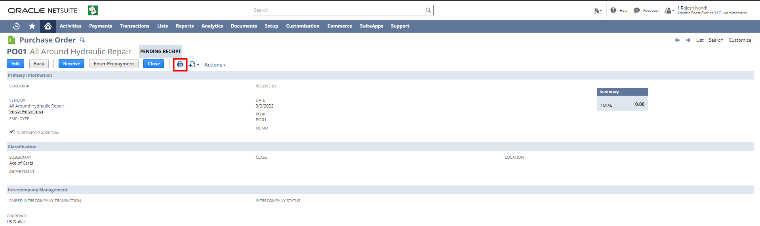
STEP 4: Once the Purchase Order is created then you have to receive them.

Click “View” button on the Purchase Order you want to receive.
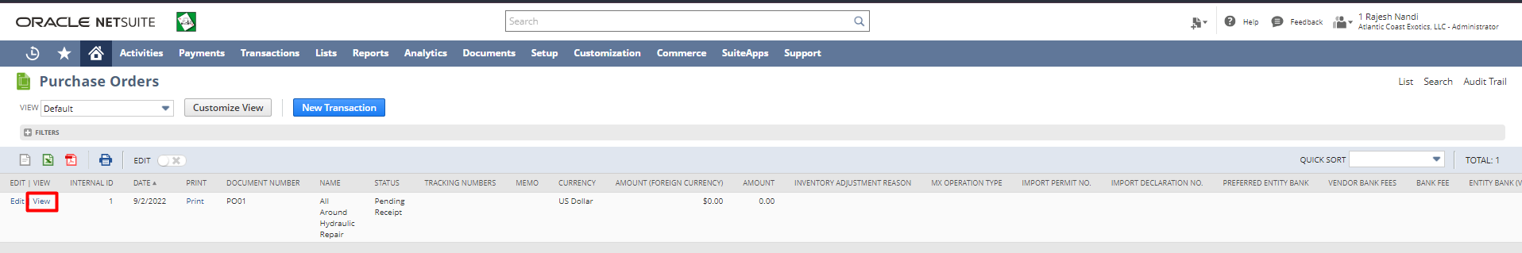
STEP 5: Click on the “Receive” button.
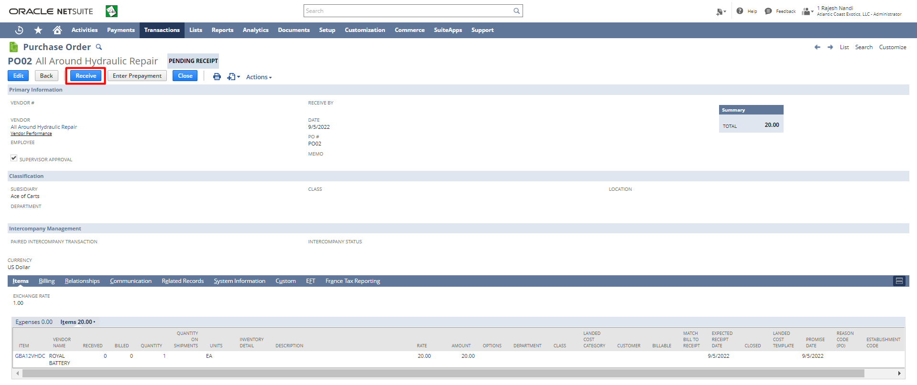
Select the Item, location, quantity and rate configure Inventory Details to receive then click the “Save” button.
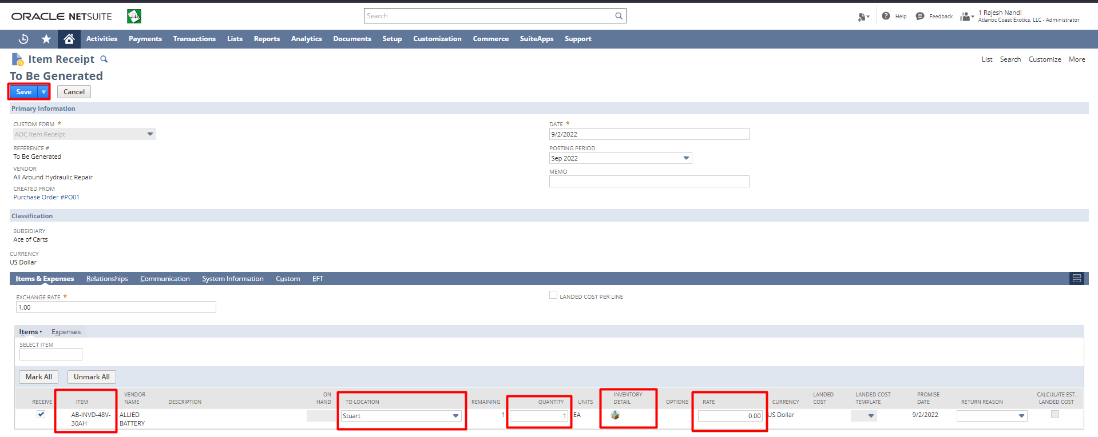
STEP 6: We can create Vendor Bills in NetSuite using Bill Purchase Orders functionality. It allows us to create a single bill for one or even multiple Purchase Orders for the same vendor.
Transactions -> Payables -> Bill Purchase Orders
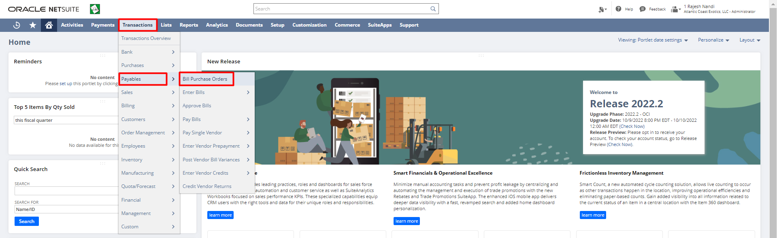
From the Vendor dropdown, select the Vendor. From the Bill list check the check box for the Purchase Orders you want to Bill. Click the “Submit” button.
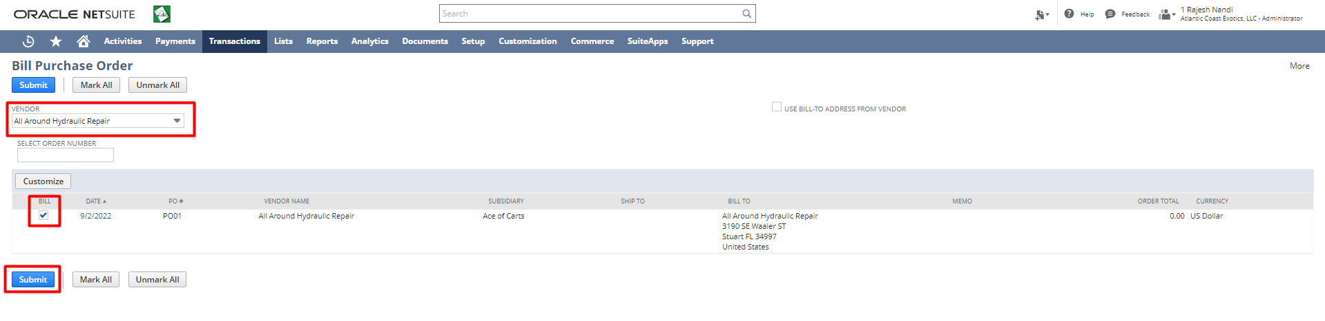
Enter the Reference No and other details if any. Click the “Save” button.
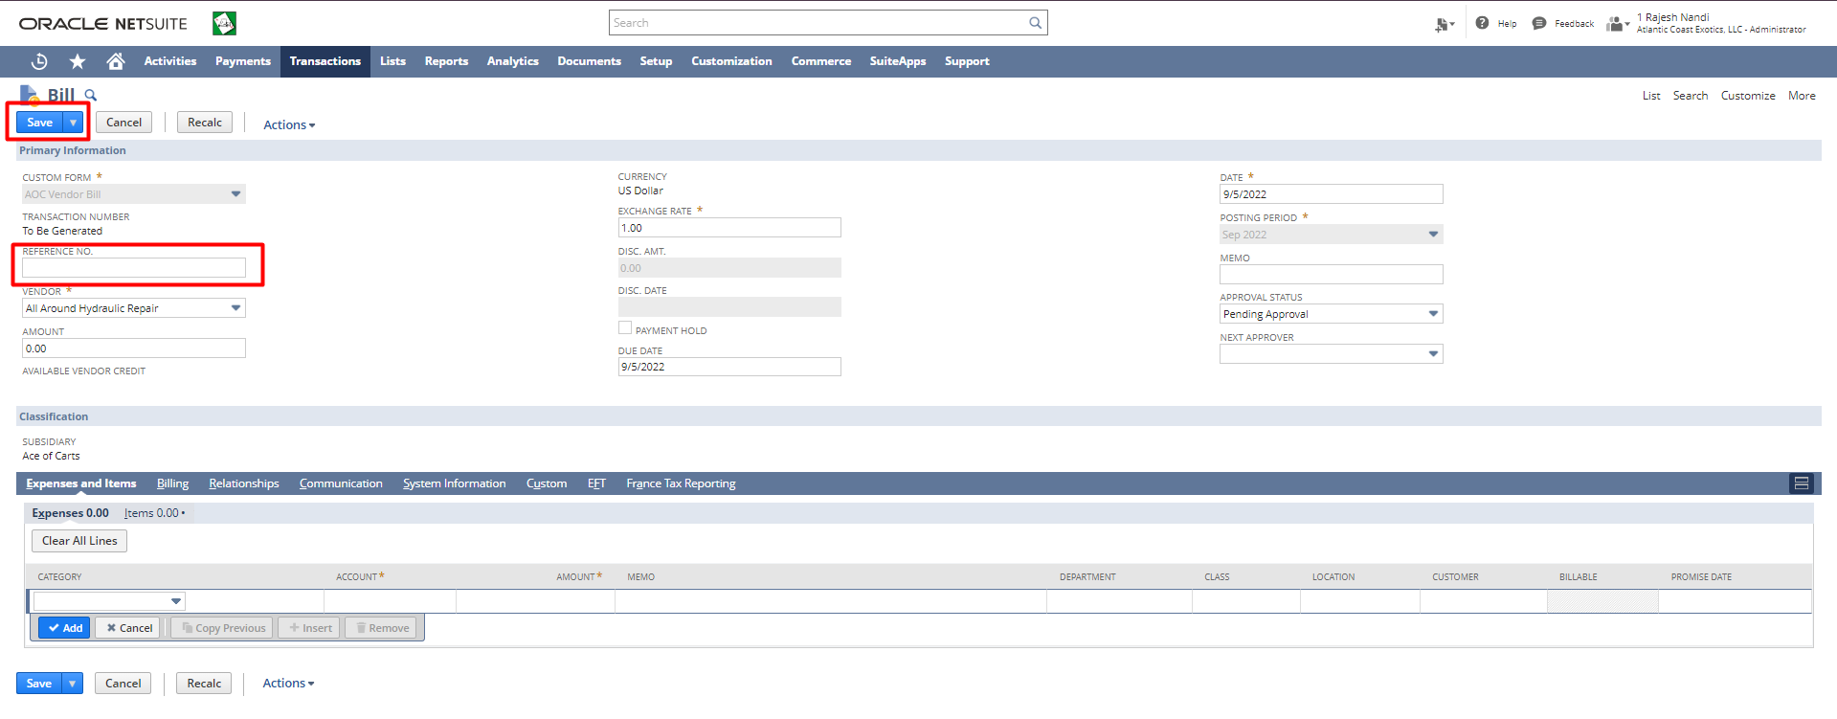
STEP 7: To make Payment for a Vendor Bill go to the Bill you want to pay.
Transactions -> Payables -> Enter Bills -> List
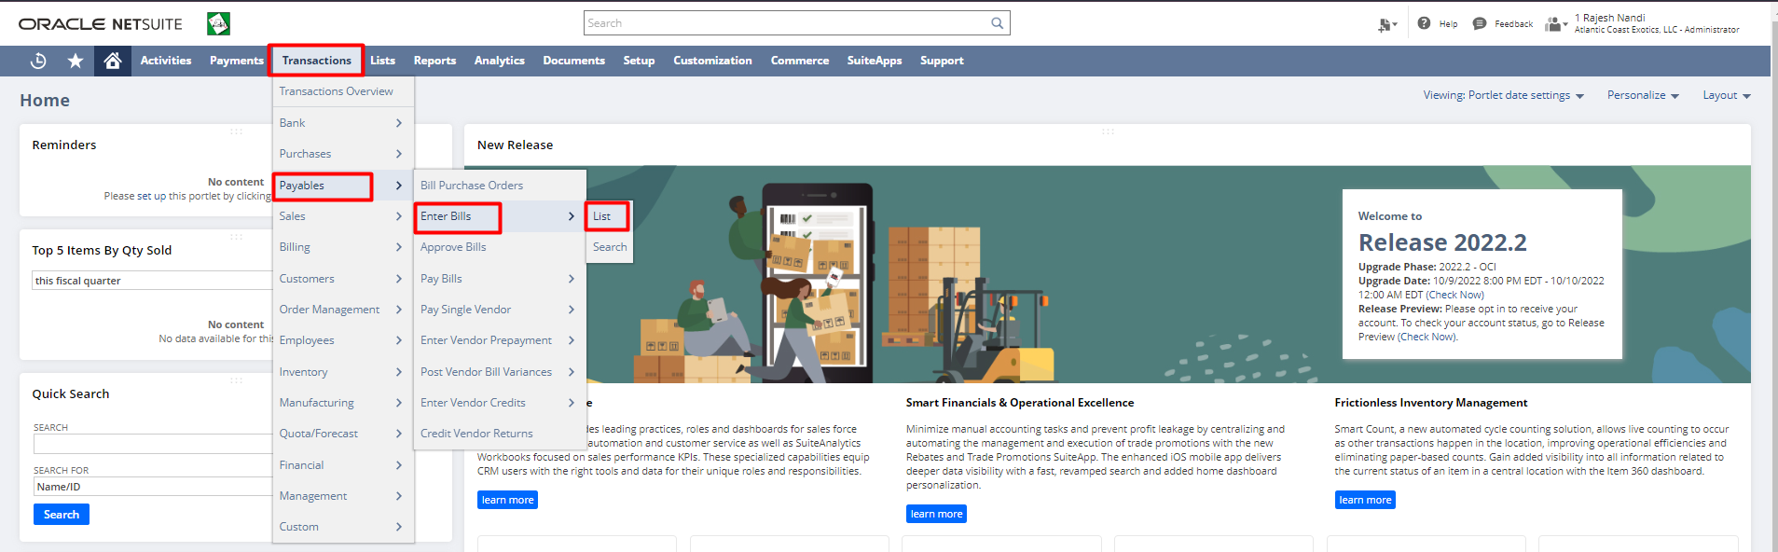
Click “View” button on the Bill for which you want to make payment.
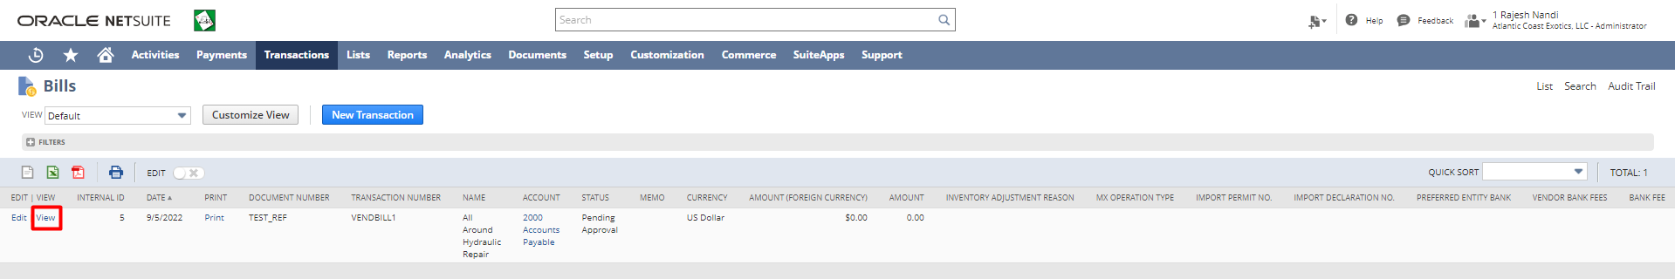

Click on the “Make Payment” button. If the make payment button will not come, then just change the Approval Status to Approved and click save.

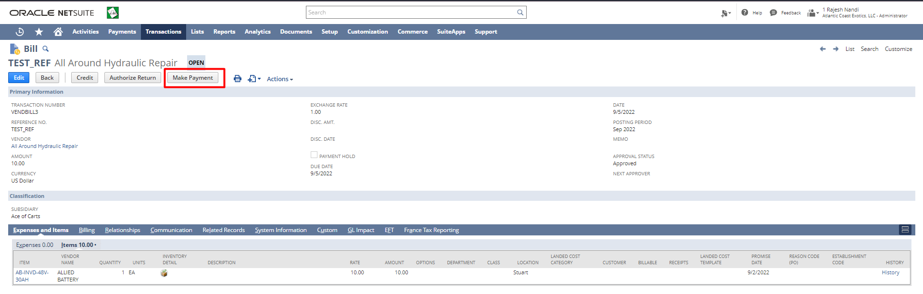
Enter other details if any for the fields in the form. Click the “Save” button.
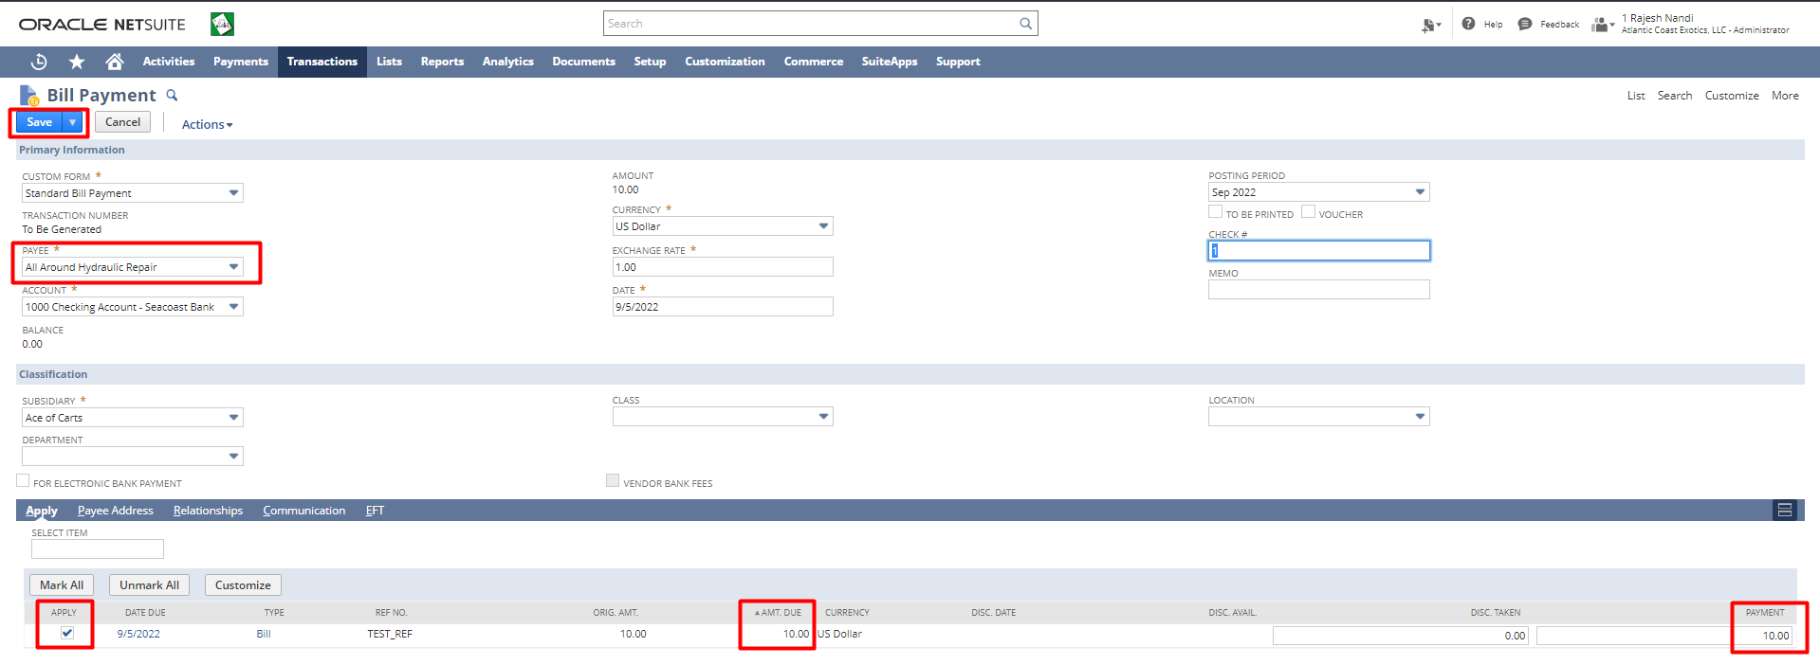
Bill Payment has been completed.
STEP 8: To Create Vendor Credit
Go to Transactions -> Payables -> Enter Vendor Credits
OR
Transactions -> Payables -> Enter Bills -> List
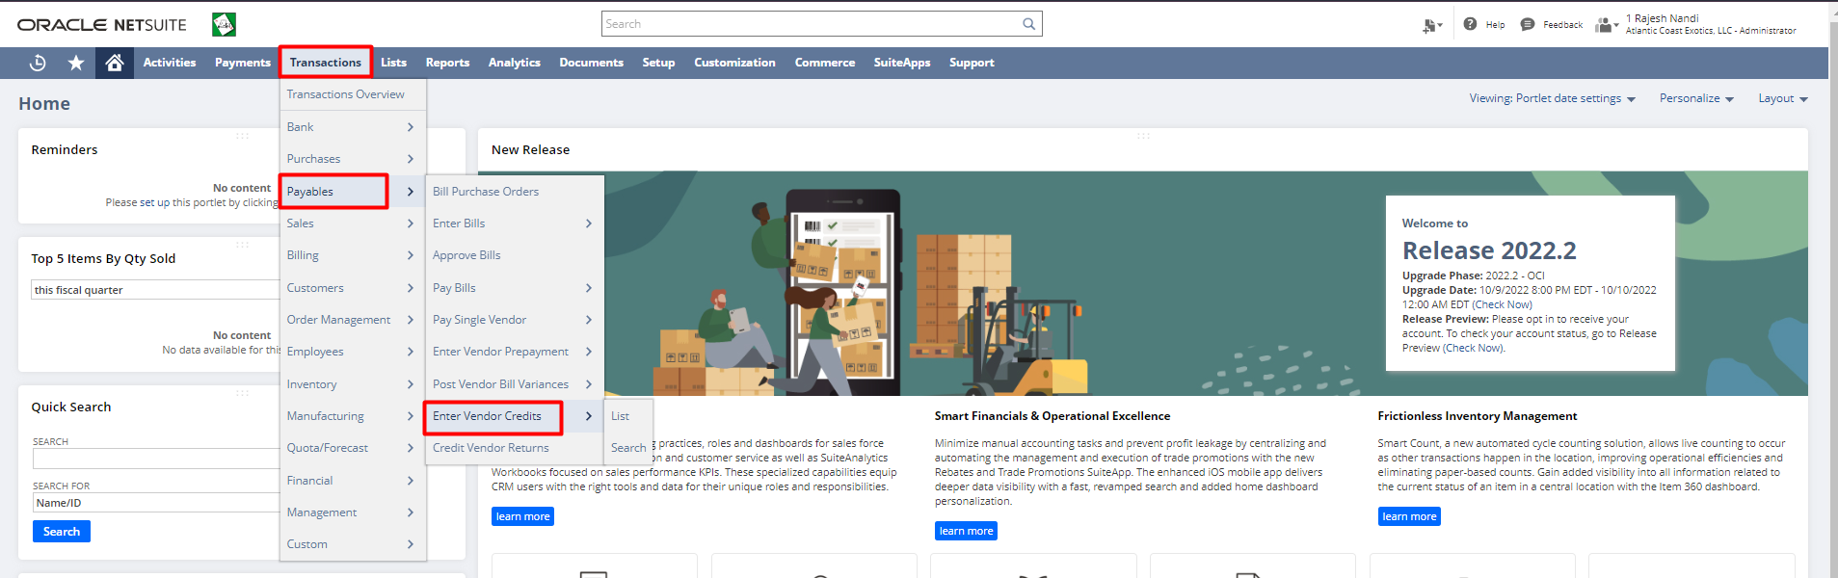
Enter credit details and save.

Click “View” button on the Bill for which you want to make Credit.
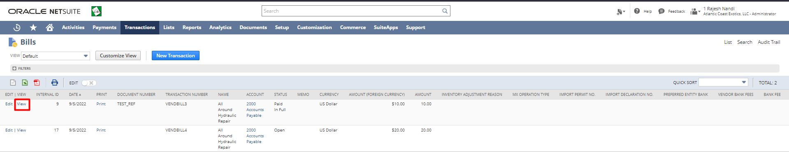

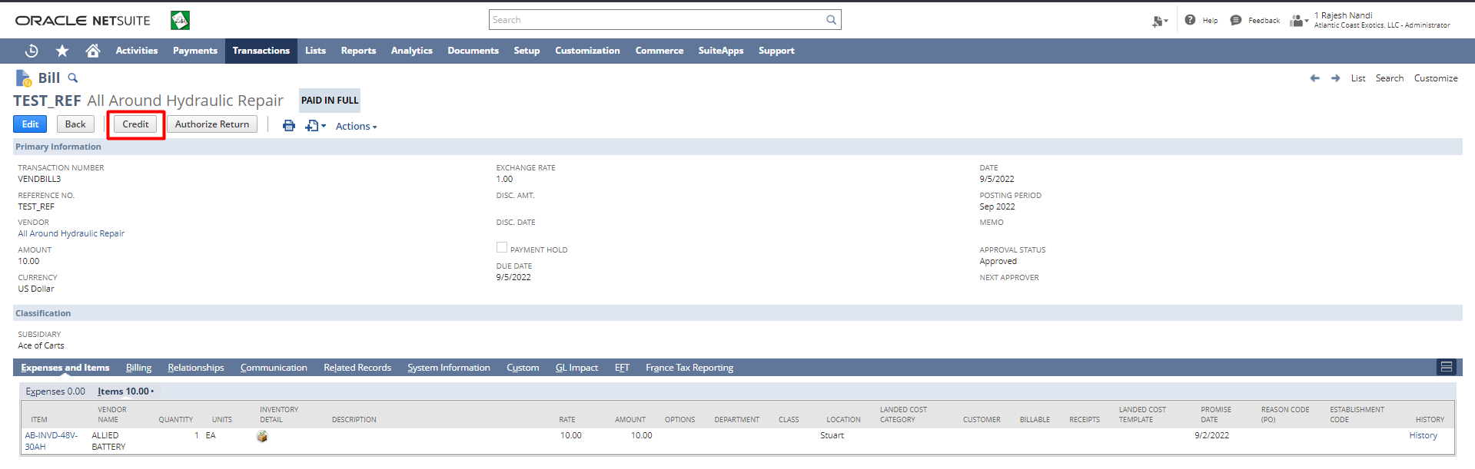

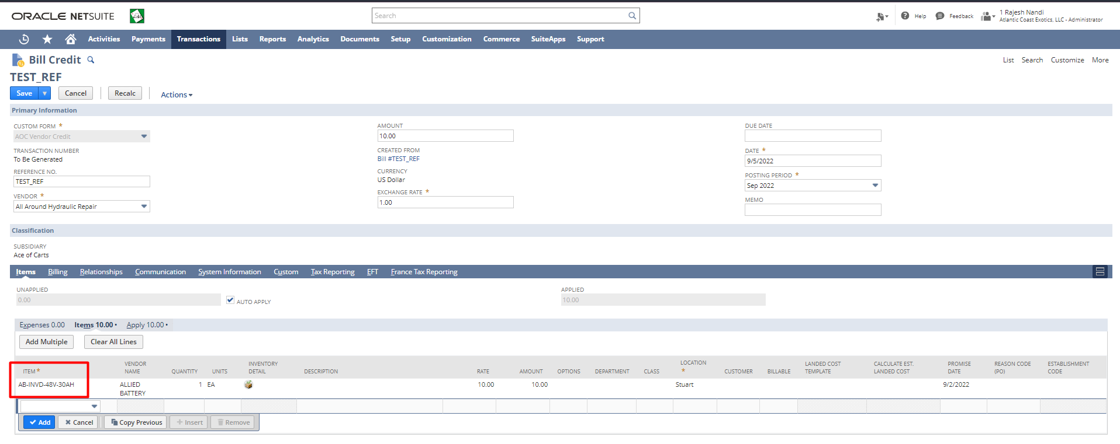
Check the box for the relevant bill under Apply under Items, and then click Save.
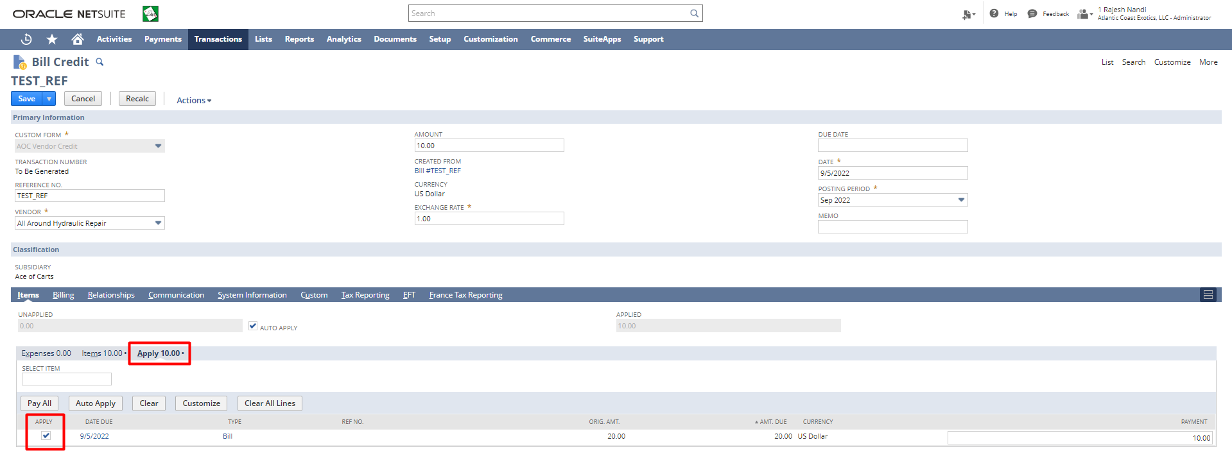
Vendor Return Authorization
It can be initiated at either the Purchase Order or the Purchase Bill. You can click on the Authorize Return button on the Purchase Bill or the Purchase Order.
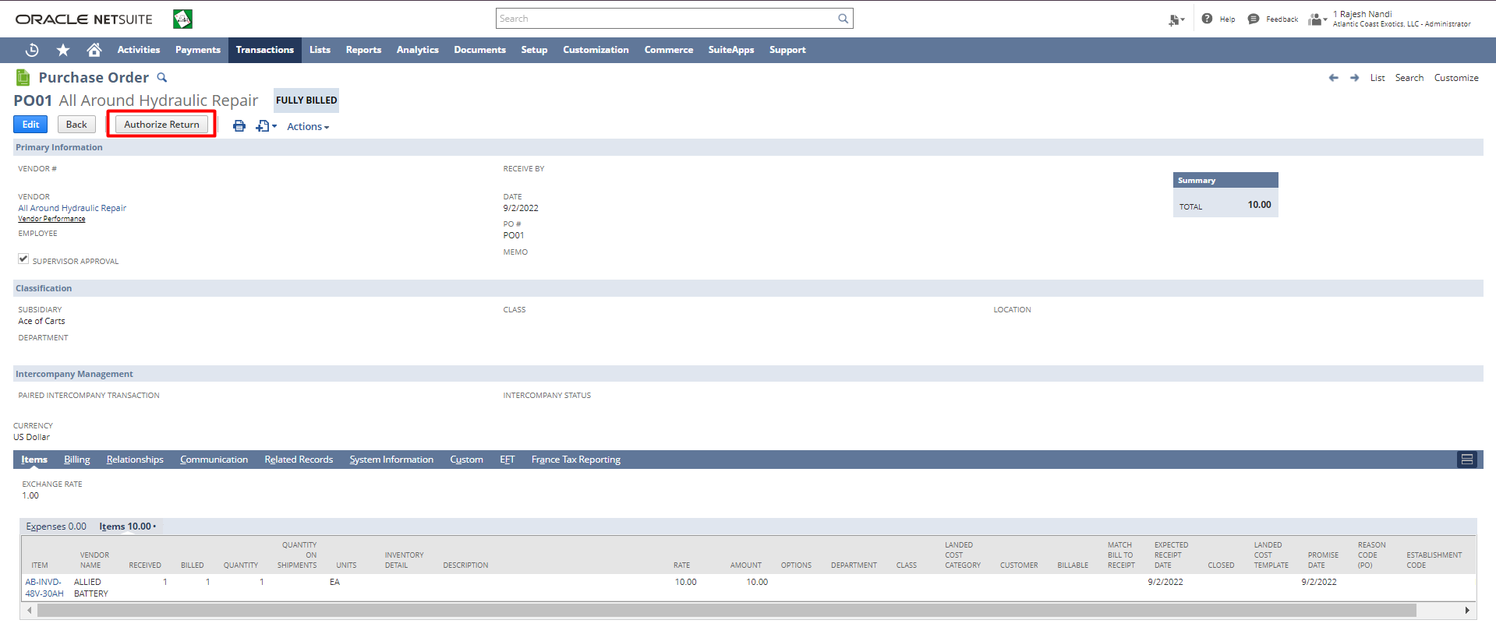

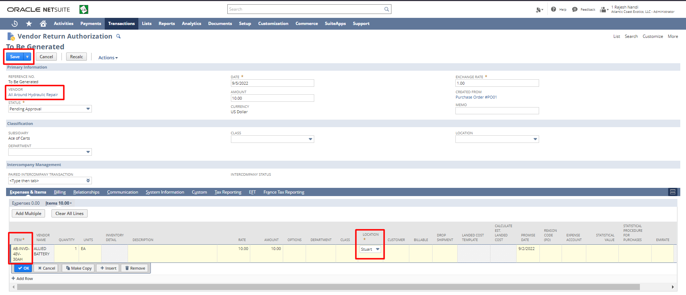
You would see all the default information will get auto loaded in the Vendor Return Authorization form, you can edit the quantity of items you wish to return. Click on ‘Save’.
Once you save the Vendor Return authorization, you need to fulfill the return of the items as it will be reduced from your inventory, to do that we navigate to Ship Vendor return authorization using the following navigation, Transaction -> Purchases -> Ship Vendor Returns.
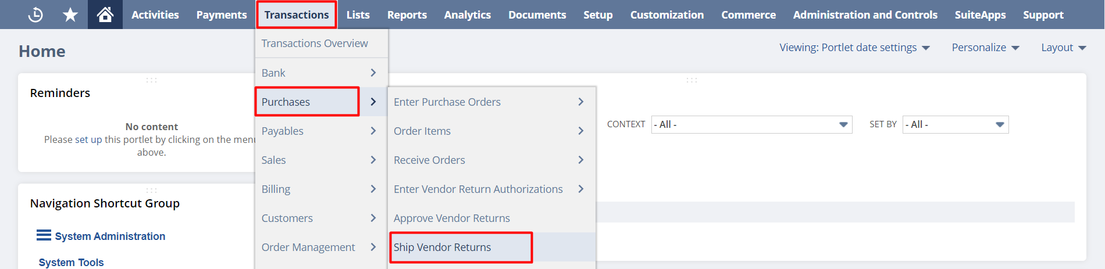
Select the appropriate Vendor return, you can filter by the vendor or directly by the return number
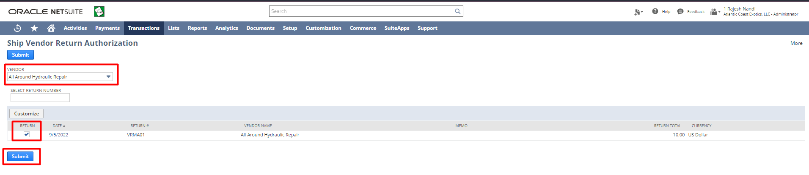
Then click on ‘Submit’.
You will be redirected to the Item fulfillment form; we recommend you cross-check the items and all the relevant details
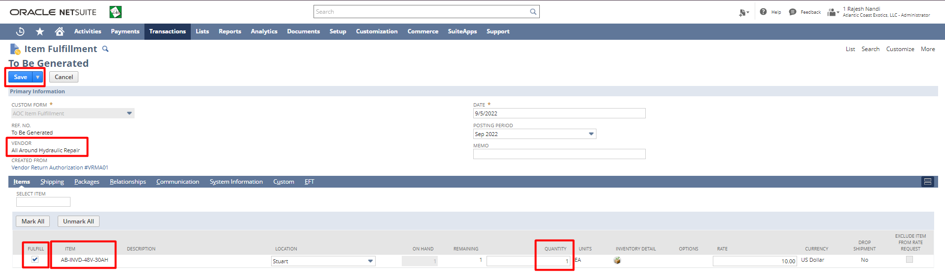
Then click on ‘Save’.

Signature: _______________________
Date: ______________________

Disclaimer:
Upon signing off on the document, you are confirming that the process has been set up per the SOW within NetSuite per your business’s needs. Any changes or modifications requested after sign-off will need to be a “change request” at an additional fee.

***PLEASE ensure that you have logged into NetSuite and tested the process prior to signing off on the setup. Paapri requires sign-off on this document prior to moving forward with any additional design meetings.

